Instructions for PWV Analysis

Documented Created By: Grant Roberts (gsroberts@wisc.edu)

Date Last Modified: 02/18/2022

# Synopsis

This guide offers instructions on how to calculate pulse wave velocity (PWV) from the cardiac 2D phase contrast (2DPC) MRI exams for subjects involved in the Longitudinal Impact of Fitness and Exercise (LIFE) study. This study is an ongoing [NIH-funded project](https://grantome.com/grant/NIH/R01-AG062167-03) lead by Dr. Ozioma Okonkwo designed to study the impact of physical activity and aerobic fitness on biomarkers of Alzheimer’s disease in midlife. The goal is to capture an individual’s global cardiovascular state by measuring PWV in the aorta. PWV is an indirect measure of vessel stiffness and, as we age, the aorta tends to become stiffer due to elastin breakdown within the vessel wall. However, aortic stiffness increases at a faster rate in the presence of cardiovascular disease, which leads to build up of fats in the vessel wall (atherosclerosis). This is exactly what we are hoping to capture with PWV. [Phase contrast MRI](https://mriquestions.com/phase-contrast-mra.html) allows us to measure blood velocities and flow waveforms over the cardiac cycle. If we can measure flow waveforms at different points along the aorta, we can then detect the time shift between these points which will allow us to calculate PWV. A simple experiment demonstrating pulse wave velocity is by placing one finger on your carotid artery and the other near your ankle where you can find a pulse. There should be a time delay, and this is exactly what PWV is. The difference in distances between the heart and these locations, as well as the stiffness of your vessels, determines this time delay.

To measure PWV in vivo, it is most common to perform breath-hold MRI scans. This is because the aorta can move during respiration which can result in image artifacts. For LIFE participants, we are acquiring breath-hold (12s) data using a [standard Cartesian acquisition](https://mriquestions.com/k-space-trajectories.html). However, the age demographic of the LIFE cohort is much older, and breath-holds may be somewhat difficult. For this study, we are also assessing the feasibility of a more advanced free-breathing [radial MRI acquisition](https://mriquestions.com/radial-sampling.html) with respiratory gating. The [respiratory gating](https://mriquestions.com/gating-methods.html) allows us to keep only data that was acquired in stationary phases of the respiratory cycle to reduce respiratory motion. The free-breathing radial acquisitions will be reconstructed into two separate datasets, one at a low temporal/spatial resolution matching the Cartesian acquisition, and another at high temporal/spatial resolutions using a [locally low rank (LLR)](https://en.wikipedia.org/wiki/Low-rank_approximation) constrained reconstruction technique. So, in total, we need to analyze 3 separate scan types: breath-hold Cartesian, free-breathing radial low resolution, and free-breathing radial high resolution. Within each scan type, we collect two imaging planes, one in the aortic arch and the other in the abdominal aorta. Between both planes, we have a total of 3 measurement points. Two measurement points in the aortic arch (ascending and descending aorta, as seen in the GIF above) and 1 in the abdominal aorta.

The following steps will thoroughly describe how I have been, from start to finish, transferring the data to the Medical Physics servers, reconstructing the free-breathing radial datasets, performing data quality assurance, and finally computing PWV using a custom user interface. I have developed several scripts for reconstruction, several Matlab scripts for quality assurance, and a graphical user interface to compute PWV. This software is freely available on Github ([https://github.com/gsroberts1/PWV_2DPC](https://github.com/gsroberts1/PWVcode)). Please feel free to email about any questions regarding the content of this guide.

# Background Information

* LIFE subjects are scanned at the Waisman Center, typically in the morning.
* During each scan session, the following cardiac scans of the aorta are acquired:
  + Anatomical - 2D [balanced steady state free precession](https://mriquestions.com/ssfp-mra.html) images (free-breathing)
    - Sagittal slices (higher resolution)
    - Coronal slices
    - Axial slices
  + Cartesian 2DPC - 2D Cartesian phase contrast images performed under breath-hold (~12 seconds each)
    - Axial slice in aortic arch (transects both ascending and descending aorta)
    - Axial slice in abdominal aorta
  + Radial 2DPC - 2D Radial phase contrast images performed with no breath-hold (~2 minutes each)
    - Axial slice in aortic arch
    - Axial slice in abdominal aorta
* After we acquire each scan, Anatomical and Cartesian 2DPC images are automatically produced on the scanner.
  + This is because we acquire them with “built-in” GE product MR sequences.
  + The images come in the format of DICOMs and are stored locally on the Waisman servers and we need to pull them across from the Waisman center to Medical Physics after each scan (see Data Transfer section below).
* However, Radial 2DPC images need to be “reconstructed” (see Reconstruction section below).
  + This is because we acquire them with a customized UW MR sequence.
  + Reconstruction is the process of creating images from raw MRI data.
  + Since we have flexibility in how we create our Radial 2DPC images, we are going to perform 2 reconstructions.
    - 1 low resolution reconstruction, matching pixel size and frame rate of the Cartesian 2DPC images.
    - 1 high resolution, high frame rate reconstruction to try and improve our data quality.
* **In total, this will give us 9 sets of images that are of interest to us:**
  + **3 anatomical** image sets (sagittal, coronal, and axial)
  + **2 low resolution Cartesian 2DPC** image sets (1 slice in aortic arch and 1 slice in abdominal aorta)
  + **2 low resolution Radial 2DPC** image sets (1 slice in the aortic arch and 1 slice in abdominal aorta)
  + **2 high resolution Radial 2DPC** image sets (1 slice in aortic arch and 1 slice in abdominal aorta) using LLR recon
* The anatomical images are used to trace a “centerline” of the aorta.
  + This is done so we can quantify the distance between measurement points from the 2D phase contrast scans.
* The 2D phase contrast scans are used for measuring flow curves.
  + There are 2 axial slices prescribed over the aorta. However, the upper slice transects both the ascending and descending aorta. This gives a total of 3 flow measurement points along the aorta: Ascending Aorta (AscAo), Descending Aorta (DescAo), and Abdominal Aorta (AbdAo).
* 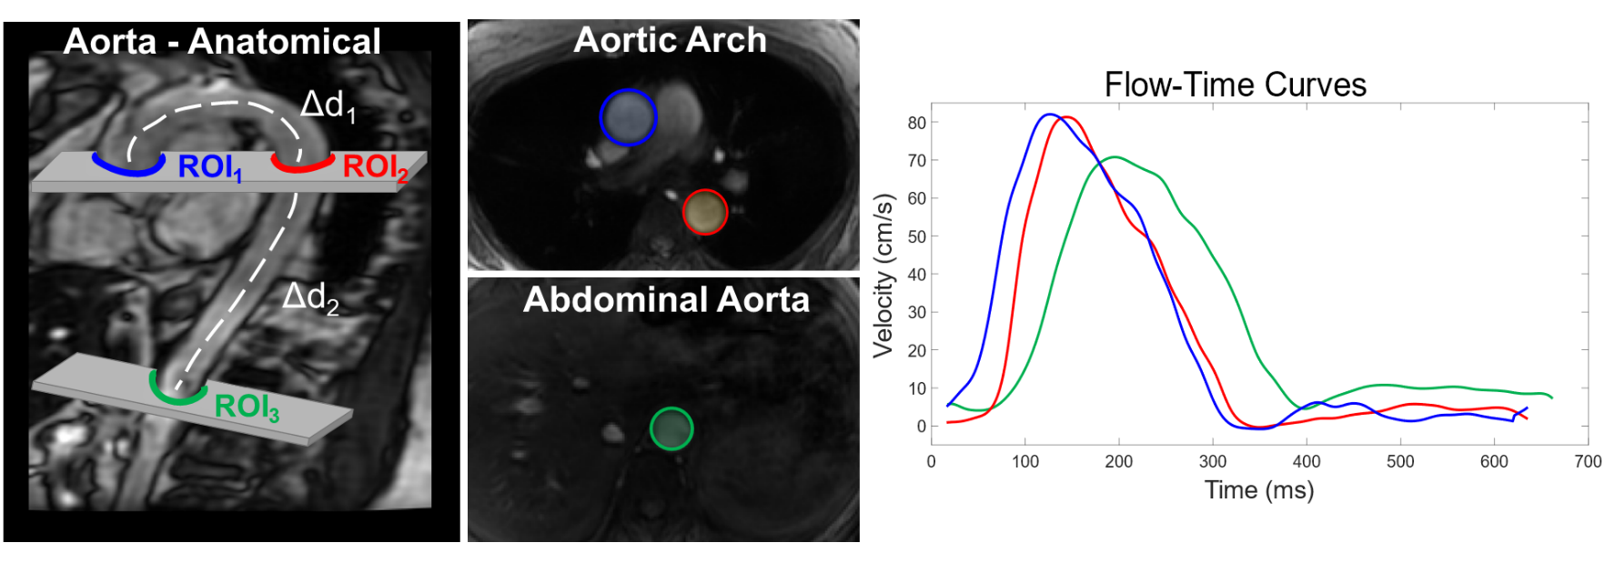If we know the distance between each of the 3 measurement points, and we can see the time lag between flow curves, then we know the time it takes for the pressure wave to travel from one point on the aorta to the other. This is the pulse wave velocity (PWV) measure we are trying to obtain.

# PWV Analysis

## Draw Centerlines

* The first step in obtaining aortic PWV is tracing an aortic “centerline”, which is a line that runs directly through the center of the aorta. This is useful because we need to determine how far apart our flow measurements are.
* Open Matlab (if not already open).
* Add the ‘PWV_2DPC’ folder to the Matlab PATH. This can be done by going to the folder where ‘PWV_2DPC’ is located, right clicking on it, selecting ‘Add to Path’, and clicking ‘Selected Folder and Subfolders’.
* Move to the LIFE directory of interest using the left panel in Matlab.
  + 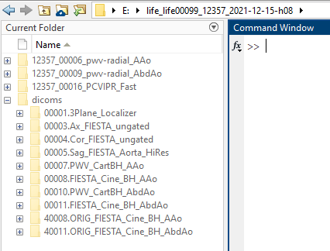There should be several folders in this directory, including a ‘dicoms’ directory.
  + When you first download a case, the ‘dicoms’ folder will contain folders that have zipped images.
    - These would have been unzipped if performing QA (see Quality Assurance section above).
  + 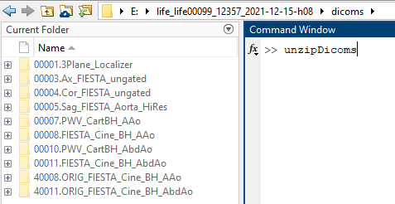If these haven’t been unzipped, do that now by moving into the ‘dicoms’ folder and typing “>> unzipDicoms” in the command window and then select the current folder when prompted.
    - This should decompress all of the images and should take a couple of minutes to run.
  + Move back into the main LIFE directory.
* In the command window, type “>> DrawCenterlines”. A user interface should open.

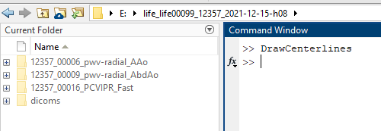

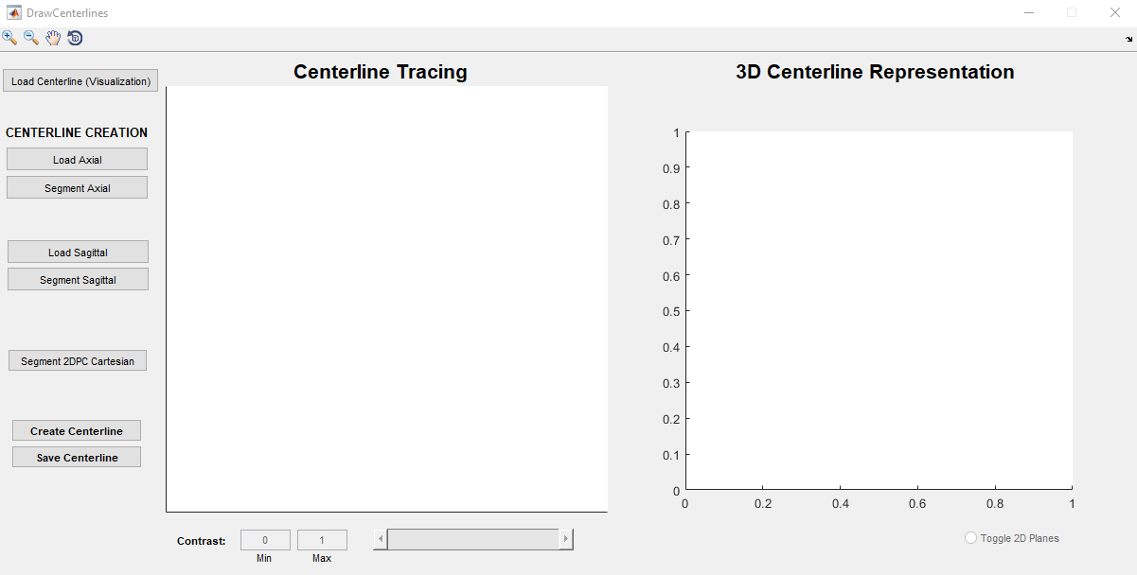

1

2

3

4

5

6

7

* **1: Load in a centerline that has already been made**
* **2: Load in axial anatomical datasets and trace points along aorta**
* **3: Load in sagittal anatomical datasets and trace points along aorta**
* **4: Load in both Cartesian 2DPC slices and mark center of aorta**
* **5: Trace a centerline through the aorta over 2 different projections (view angles)**
* **6: Interactive plot for tracing aorta**
* **7: Interactive plot of the 3D aortic centerline**
* (Step 1) We can skip the first button since we are loading a new case. We will not be able to “load a centerline” since we don’t have one saved for this case yet. However, after we create and save our centerline, we can go back at any time and load in and visualize it using the “Load Centerline (Visualization)” button.
* (Step 2) Our first step will be to load in the 2D axial images. Click the ‘Load Axial’ button. This should open a pop-up screen where you need to select 1 axial DICOM image.
  + 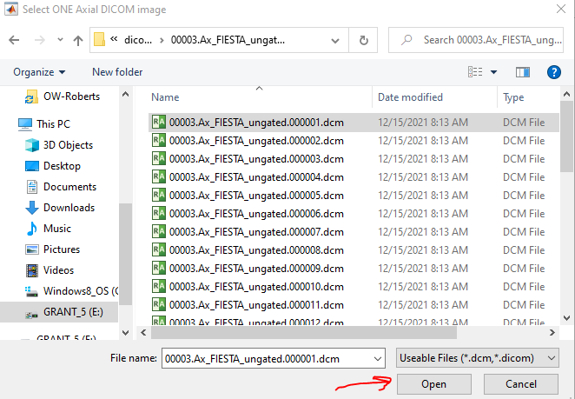Navigate to the ‘dicoms’ directory, select the ‘0000#.Ax_FIESTA_ungated’ folder, click on one of the DICOM images (it doesn’t matter which), and then select ‘Open’ on the bottom of the popup window.
  + This will load all of the axial slices for this subject. Note that these are just anatomical/structural images.

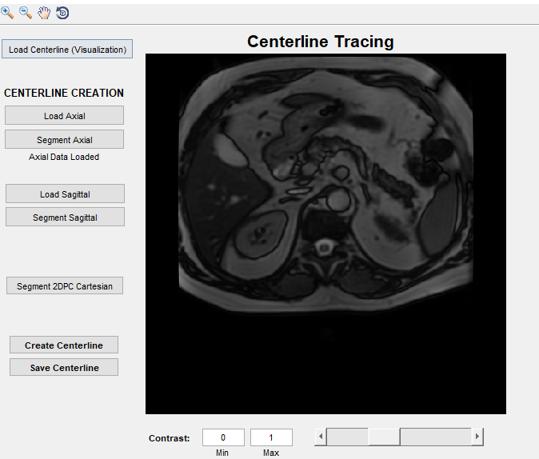

Contrast

Slice Slider

* + - You can use the bottom slider to adjust the slices up/down and you can change the numbers in the contrast boxes to change the “window/level” of the image (to adjust the brighness and contrast). The contrast values need to be between 0 and 1 and the ‘Min’ value has to be less than the ‘Max’ value.
  + **I would suggest scrolling through these images at least once, using the bottom slider, to (1) become familiar with images, (2) look for any strange features, and (3) pinpoint where the aorta is in each slice.**
* When you are ready to trace the aorta, click the ‘Segment Axial’ button.
  + Starting from the bottom slice, you will need to left-click on the mouse where the center of the aorta is.
  + For example, here is the first slice. Note that the mouse click shows as a blue/purple asterick.

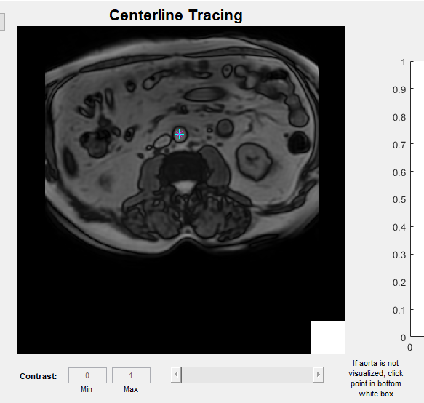

* + - If the aorta cannot be seen on the image, click on the bottom right white box. This will occur once the slice moves above the top of the aortic arch. There may be cases where the images don’t look great and the aorta can’t be visualized. You can use the white box for this case also.
  + After selecting a point in the aorta, move to the next slice by hitting ‘Enter’ on the keyboard.

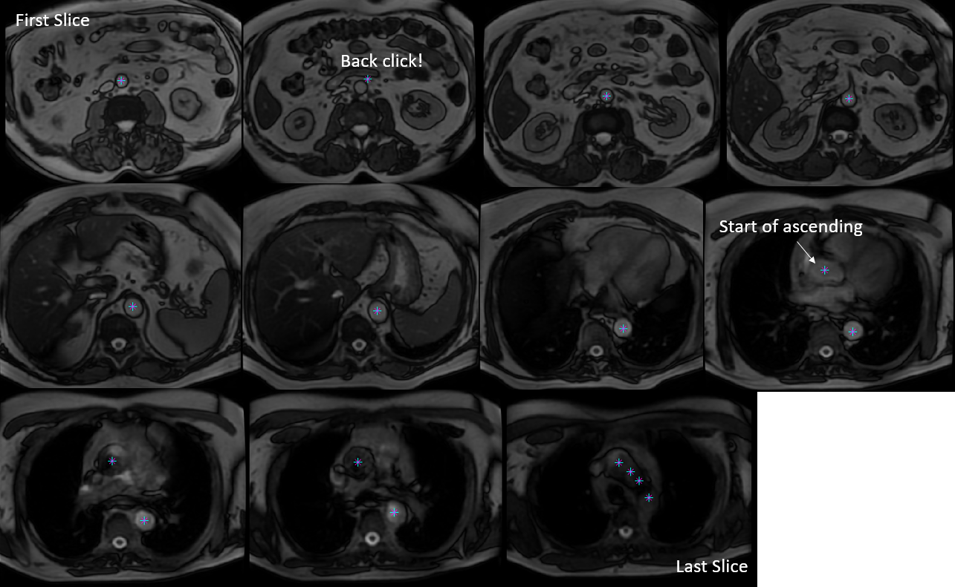

Bad click!

* + After tracing the aorta over all slices, you should see the points you selected in 3D
    - These are displayed as physical coordinates (relative to the center of the MRI scanner).
    - Coordinates are obtained using the DICOM header patient position and oritationtation data.

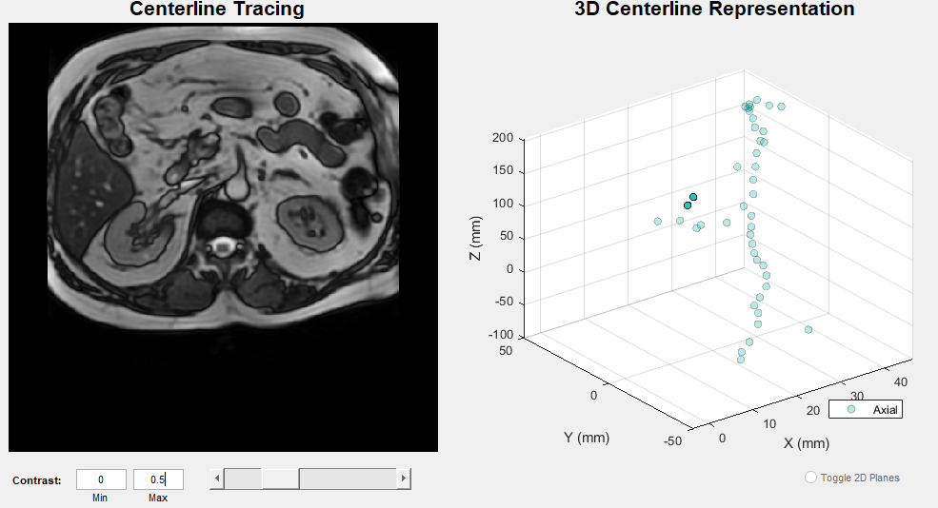

**Brighter image**

**Selected Points in 3D space**

* + You don’t need to do anything with the plot on the right, but you can rotate it and zoom if you want.
* 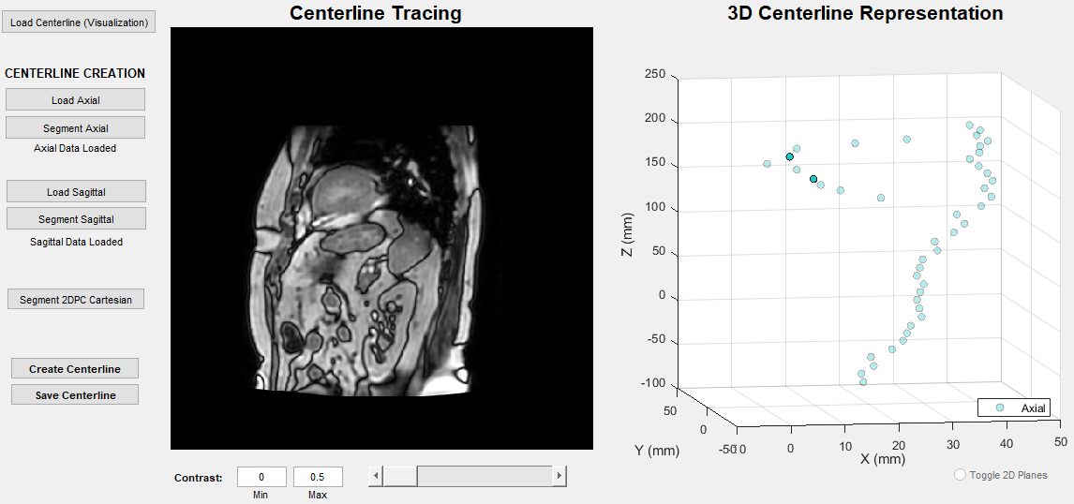(Step 3) Click the ‘Load Sagittal’ button to repeat the process for the sagittal images. The sagittal DICOM images should be located in the ‘0000#.Sag_FIESTA_Aorta_HiRes’ folder.
  + Again, scroll through the images to get a feel for where the aorta is in each slice. Change the contrast if needed.
* 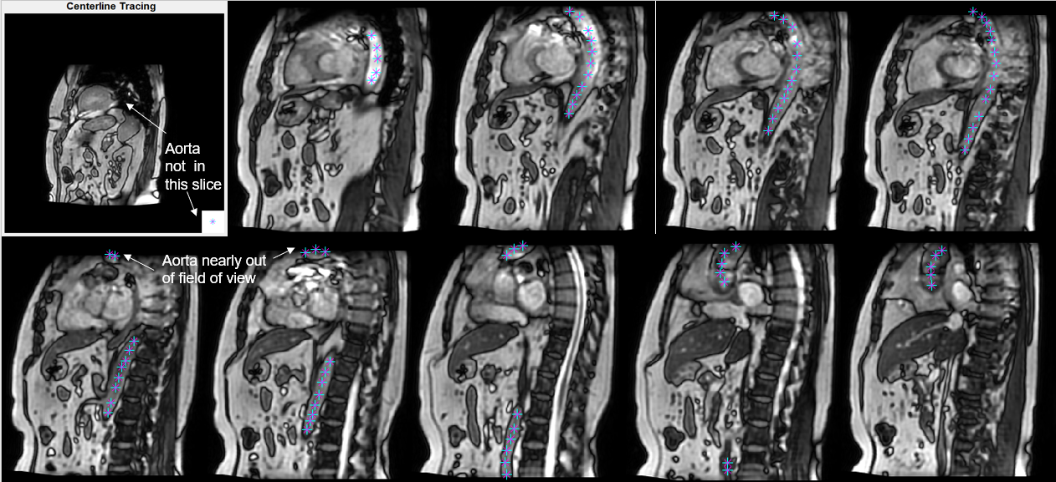When ready to trace the aorta, click ‘Segment Sagittal’ button.
  + Left click to fill in points over the aorta. You don’t have to make too many points, just enough to get a good idea of the overall shape of the aorta.
  + Notice that, in this example, the sagittal and axial images were prescribed too low. The arch of the aorta is nearly out of the field of view (on the top of the image). However, we can still get a good idea of where the aorta is at. I would suggest making a note in the ‘Comments’ column in the Excel sheet ‘Analysis’ in ‘SUMMARY_PWV_VISIT#’.
  + You will likely not see the aorta in the first few slices and the last few slices, make sure to click the white box in the bottom right of the image if you do not see the aorta.
  + This is typically the hardest view to trace because of image “[artifacts](https://en.wikipedia.org/wiki/MRI_artifact#:~:text=An%20MRI%20artifact%20is%20a,present%20in%20the%20original%20object.)”. Since we aren’t doing the anatomical scans under breath-hold and because there is strong flow in the aorta, we may see zebra-stripe lines across the image (called banding artifact), or we may not even see the aorta at all in certain slices. Also, the pulmonary artery runs right underneath the aortic arch. This sometimes make it hard to determine what is aorta and pulmonary artery.
  + **Just try your best with the centerline tracing. If you feel that it is impossible to segment or you are having trouble finding the aorta, don’t hesitate to email me to reach out for help!**
  + After we have traced the aorta over all slices, we can see our points in 3D along with the points from the axial centerline tracing. Notice that the points from both scans line up quite well (as they should) and that we can start to see the overall shape looking something like an aorta.

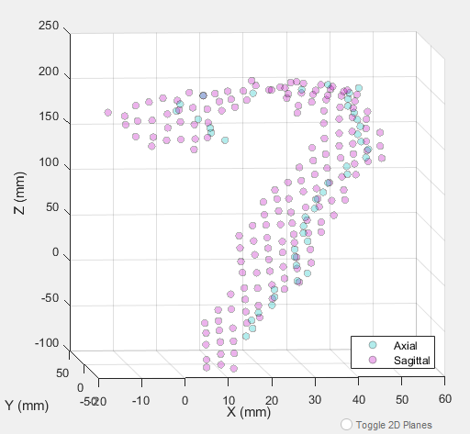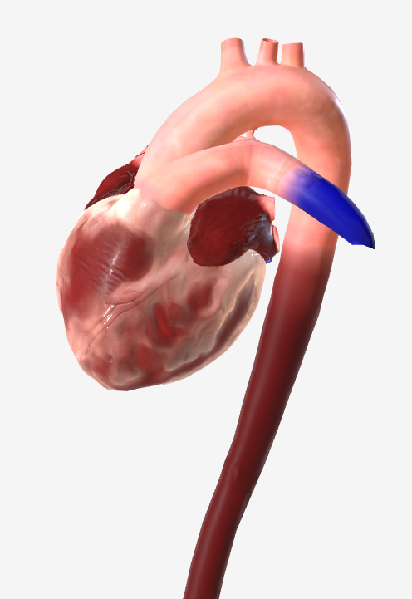

* (Step 4) Now, we need to define where our flow measurement points will be. Remember, this is the ascending aorta (AscAo), descending aorta (DescAo), and abdominal aorta (AbdAo). Also remember that the AscAo and DescAo measurement points are in the same 2DPC slice.
  + Click ‘Segment 2DPC’ Cartesian
    - Find the ‘000##.PWV_CartBH_AAo’ folder. Go into the folder, click on any of the DICOMs, and click ‘Open’.

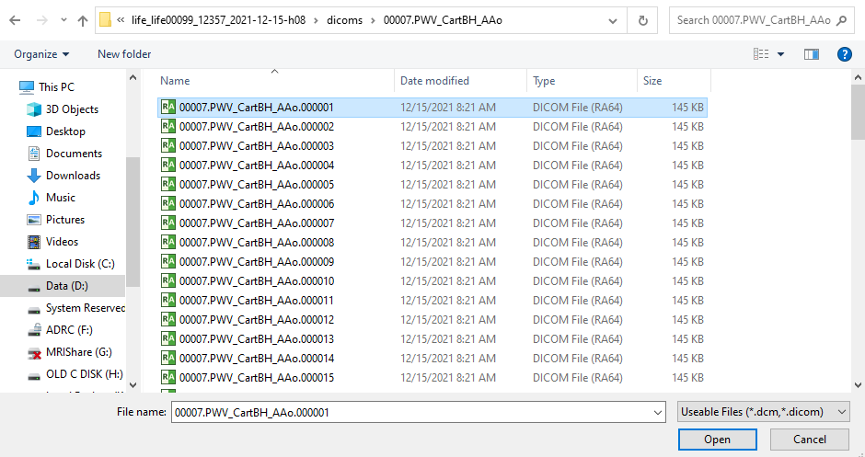

* + You should now see the slice of the aortic arch from the *first* 2DPC Cartesian sequence.
    - Left-click in the middle of the ascending aorta first, then click the descending aorta.
    - 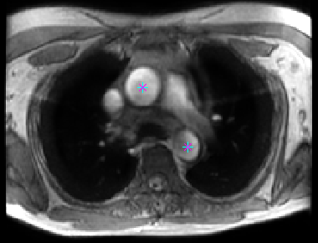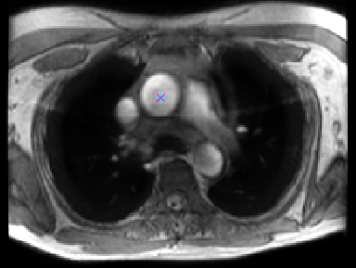**IMPORTANT: Make sure to click the ascending aorta before the descending aorta!**
    - Click ‘Enter’ on your keyboard. You should see these points appear in the ‘3D Centerline Representation’ plot as black dots. They should line up closely with the other points that you have selected.
  + We now need to load in the abdominal aorta 2DPC slice. Click ‘Segment 2DPC Cartesian’ again.
    - Find the ‘000##.PWV_CartBH_AbdAo’ folder. Go into the folder, click any of the DICOMs, and click ‘Open’.
  + You should now see the slice of the abdominal aorta from the *second* 2DPC Cartesian sequence.
    - 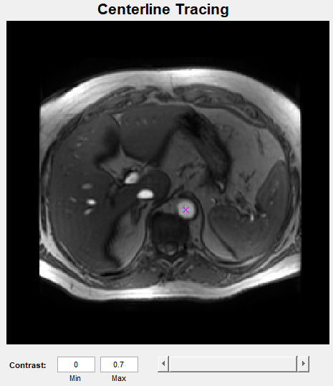Click in the middle of the abdominal aorta and then hit ‘Enter’ on your keyboard.
* On the 3D Centerline Representation plot, we should now see all of the points (colored) from the anatomical images for the centerline tracing and you should see 3 points where we will take our flow measurements (black).

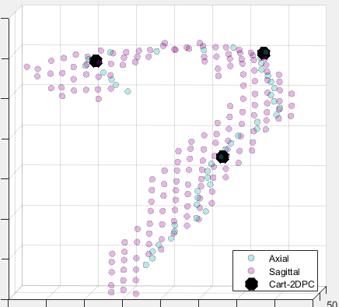

* (Step 5) We are ready to trace our aortic centerline. Click ‘Create Centerline’.
  + We will first trace the aorta in a ‘Coronal’ projection. In other words, we will trace a line along the aorta like we are looking at it from the front of the subject to the back.

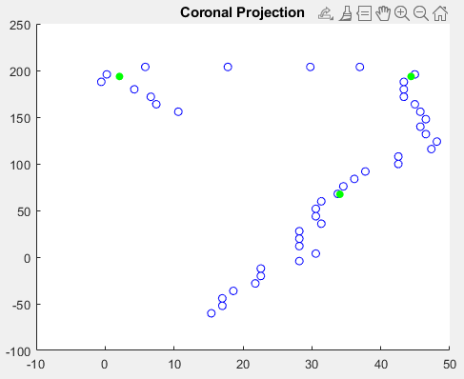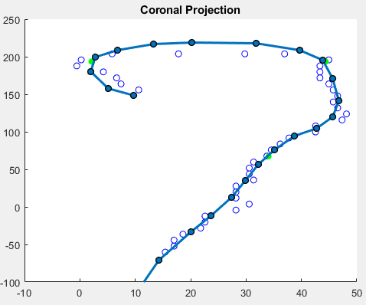

* + - To trace, just click points along where you think the aorta should run and it will connect the dots automatically. I usually select around 20-30 points.
      * Note that I went a little high on the arch. This is because I knew that some of the arch was cut off in the anatomical images.
      * Also note that the green points are the points we selected from the 2DPC Cartesian images. Try your best to go through those with your centerline trace.
      * Try to make the centerline tracing as smooth as possible while still “connecting the dots”.
    - Once you are finished, hit ‘Enter’.
      * 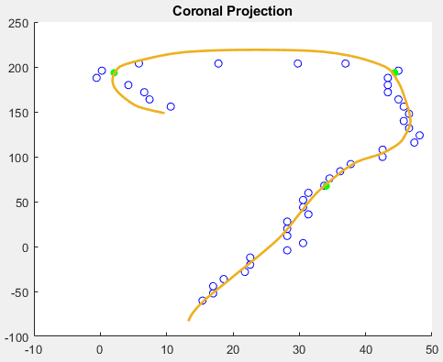You should see smoothed centerline in the coronal (or front-to-back) view.
  + We can now perform the same procedure in the ‘Sagittal’ (side-to-side) view.
    - This view is much easier to trace because we our sagittal anatomical images are better resolution than our axial images (and thus have more data points).

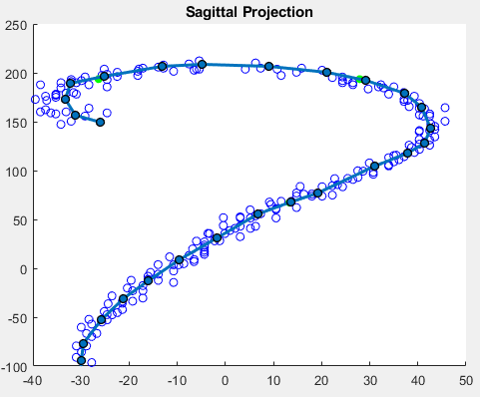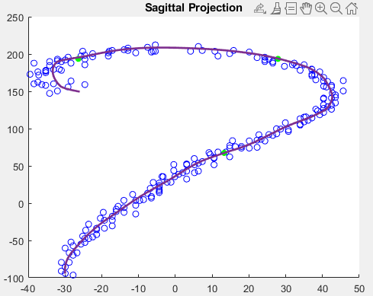

* + We can now look at the finalized aortic centerline alongside our 2DPC slices in the 3D Centline Representation plot. We can rotate the image around in 3D to check and make sure everything looks good. We can also remove the 2D planes by clicking ‘Toggle 2D Planes’.

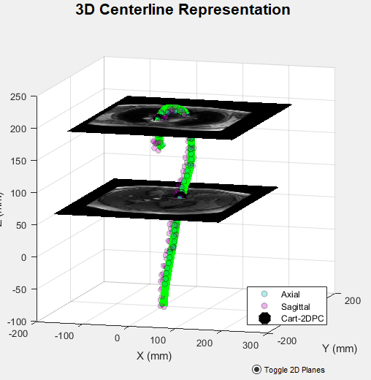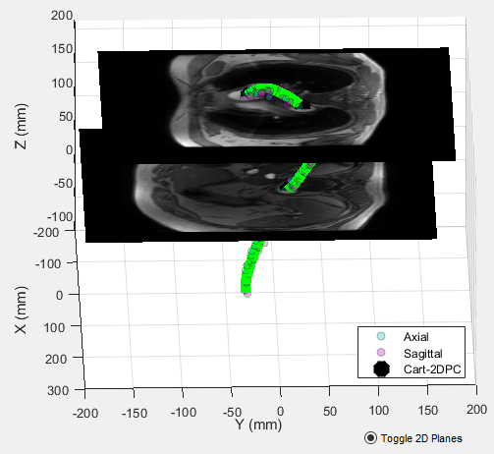

* (Step 5) The last step is to save the centerline that we have just created. Click ‘Save Centerline’.
  + This will save our centerline in ‘.mat’ format and will be called ‘anatCLdataset.mat’.
    - Files that are ‘.mat’ are data files specific to Matlab.
  + It will ask us to select the folder that we want to save it in. Save it in the main LIFE directory.

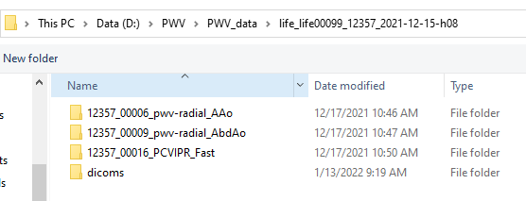

* + This will also create a new folder called ‘CenterlineData’ that contains images of the traces that we made and a snapshot of the final 3D centerline plot.
* We can now exit out of the ‘DrawCenterlines’ interface.
* (Step 1) If we want to in the future, we could open up ‘DrawCenterlines’ and click the ‘Load Centerline (Visualization)’ button at the top to visualize the centerline that we just made.

## Analyze Flow Waveforms

* After we have made our centerlines, type “>> close all; clear all; clc” in the Matlab Command Window to remove all plots, variables, and clear the command window screen.
* Type in “>> PWV_2DPC” to open up the interface that we will use to analyze our flow data.
  + You should see the following window pop-up.

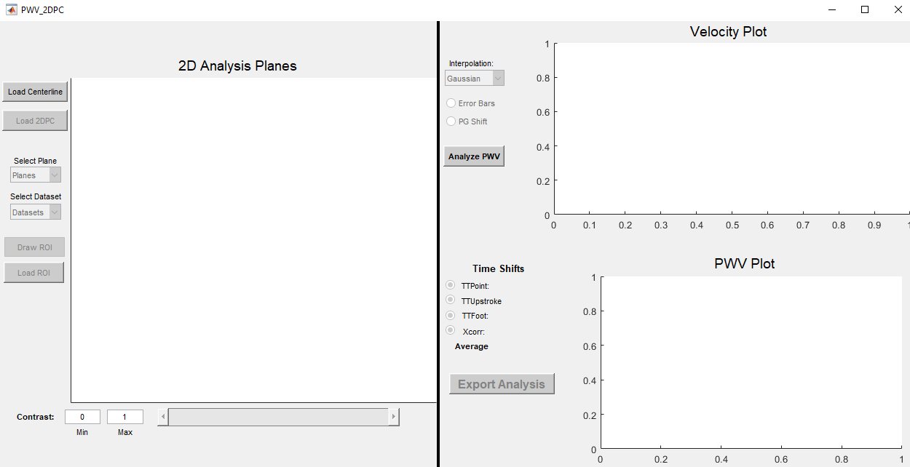

1

2

3

4

5

6

* **1: Load in the pre-made centerline**
* **2: Load in Cartesian/Radial 2DPC slices**
* **3: Draw circular ROIs over our measurement points (AscAo, DescAo, AbdAo)**
* **4: Calculate flow and load the flow curves**
* **5: Analyze time shifts and compute PWV**
* **6: Save PWV data**
* 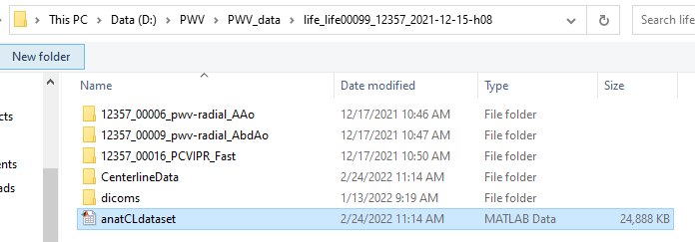(Step 1) Select ‘Load Centerline’. This will prompt you to find/select the ‘anatCLdataset.mat’ that we just created in the above section.
* (Step 2) If loaded successfully, you will see a clickable ‘Load 2DPC’ button and text that reads “Centerline Loaded”.
  + The ‘2D Analysis Planes’ panel is designed for the interactive manual [segmentation](https://www.mathworks.com/discovery/image-segmentation.html) of the aorta (classifying what is aorta and what is not). This is required because we want only the blood velocity information contained within the aorta to measure our flow waveforms.
  + **Note that we will have to repeat this analysis (starting from the beginning of this section) 3 times. This is because we have 3 different 2DPC datasets. We have (1) Cartesian 2DPC data that is low spatial resolution and low temporal resolution, (2) Radial 2DPC data that is low spatial resolution and low temporal resolution, and (3) Radial 2DPC data that was reconstructed with high spatial resolution and high temporal resolution.** 
    - For now, let us focus on the Cartesian 2DPC data.
  + Click the ‘Load 2DPC’ button.
    - Find the ‘000##.PWV_CartBH_AAo’ folder and select any of the DICOM images.
    - 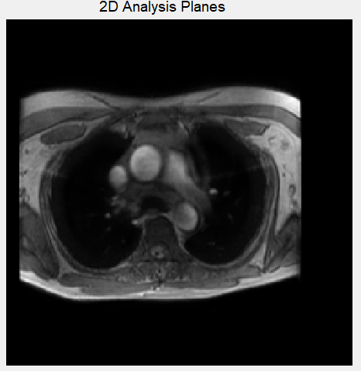An image should appear in the ‘2D Analysis Planes’ panel and there should be text that reads ‘Plane #1 loaded” under the ‘Load 2DPC’ button.
    - You should recognize this image; it’s the same image we saw in Step 4 of the last section.
  + Click the ‘Load 2DPC’ button a second time.
    - Find the ‘000##.PWV_CartBH_AbdAo’ folder and select any of the DICOM images.
    - After loading, you will not see an image of the abdominal aorta appear automatically. However, you should see text that reads “Plane #2 Loaded” under the ‘Load 2DPC’ button.
  + You can use the ‘Select Plane’ dropdown menu to select either of the 2DPC planes you just loaded in, labelled “Plane1” and “Plane2”. Selecting either of them will update the image on the right.
  + The ‘Select Dataset’ dropdown will allow you to display several forms of images:
    - **MAG = time-averaged magnitude (1 image)**
      * This is a conventional MRI image that you are likely used to seeing (like the anatomical images we used to trace centerlines). We call it magnitude because the gray values in the image represents the overall “magnitude” of the signal we acquire from the MRI scan. When we perform phase contrast exams, we also get these magnitude images, in addition to several other images which I explain below. Since our exam breaks up images into different frames over the cardiac cycle, we have multiple magnitude images (e.g. 40 or 80). Time-averaged means that we combine these images by averaging them over all frames. This gives us better quality images.
    - **V = time-averaged velocity (1 image)**
      * This image represents the velocity (or speed) of each pixel over the scan. For every MRI acquisition, we have both [phase and magnitude](http://mriquestions.com/real-v-imaginary.html) information. When using phase contrast sequences, we use the phase information and turn it into clinically meaningful velocity information. You will notice that static tissues (like fat) will have a gray appearance. This is because they are not moving. However, vessels and the surrounding air around the patient will have bright or dark values because there is motion associated with these regions, either moving towards our feet (bright) or towards us (dark). Again, this image is time-averaged, meaning is the average velocity over the cardiac cycle.
    - **CD = time-averaged complex difference (1 image)**
      * This is the “complex difference” image. Without getting into too much detail, this image is a combination of the magnitude and velocity datasets. The goal is to highlight just the vessels and make the air and background tissue black. I’ve noticed that these images don’t turn out very well in the aortic arch, likely because there are flow artifacts in the magnitude image.
    - **mag = time-resolved magnitude (40/80 images)**
      * These are the magnitude images over each cardiac time frame (earlier frames represent [systole](https://en.wikipedia.org/wiki/Systole), when the heart contracts, and later frames represent diastole). These should be lower quality than the time-averaged magnitude image (MAG) because our data is spread out over 40/80 time frames.
    - **v = time-resolved velocity (40/80 images)** 
      * These are the velocity images over each cardiac time frame.
      * 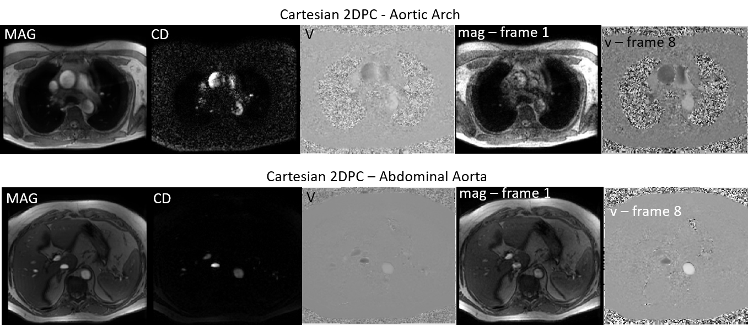This is the dataset that we will use to create our “flow curves” which show blood flow within a vessel over the cardiac cycle.
  + For images that have multiple frames (‘mag’ and ‘v’), there is a slider at the bottom of the panel that allows you to scroll through each time frame.
  + You can also “window/level” the image adjust the brighness and contrast) by changing the numbers in the contrast boxes. The contrast values need to be between 0 and 1 and the ‘Min’ value has to be less than the ‘Max’ value.
  + **Before vessel segmentation in Step 3 (below), I would suggest displaying the time-averaged magnitude image by selecting ‘MAG’ from the ‘Select Dataset’. For me, this has been the best image for aorta segmentation.**
    - Note that even though we usually segment from the ‘MAG’ image, we can apply that same vessel segmentation to the other images (‘CD’, ‘V’, ‘v’, or ‘mag’) because all of these images are perfectly aligned with each other (i.e., registered) meaning they have the same coordinates. In other words, the pixels that we classify as “aorta” in the ‘MAG’ image will be the exact same pixels in the ‘v’ image.
* (Step 3) When we are ready to place regions of interest (ROIs) over the aorta, click ‘Draw ROI’.
  + **We first want to segment the ascending aorta (AscAo).**
  + Here a warning message will popup and will read “Press enter when the ROI is set”. Click ‘OK’.
  + Now if you put your cursor over the image, you will see crosshairs. You can now draw a circular ROI by clicking and dragging around the aorta. Once you are convinced that the aorta is encompassed by this circle, let go of the left click and the green circle should remain on the image.
    - You can shift the circle around or make it smaller/bigger by dragging the control points on the green ROI.
    - Note that the ROI doesn’t have to perfectly contour the vessel boundary; as long as you get most of the vessel in the ROI, it won’t change the shape of the flow waveform that much so don’t worry if isn’t perfect.
  + Once you are satisfied with the placement of the ROI, hit ‘Enter’ on your keyboard.
    - This tells Matlab that you are done with segmentation. If you clicked ‘Enter’ and think you should re-do the segmentation, you will need to start over. There is currently no way to delete the ROI.
  + **Please make sure that you draw the ROI for the ascending aorta first**. This is because the pulse wave from the heart will arrive first in the ascending, then travel to the descending. Doing this in reverse, the program will think that there is a negative PWV. Also, make sure that you can identify the ascending and the descending aorta. The descending aorta should be located more posteriorly, near the thoracic spine.

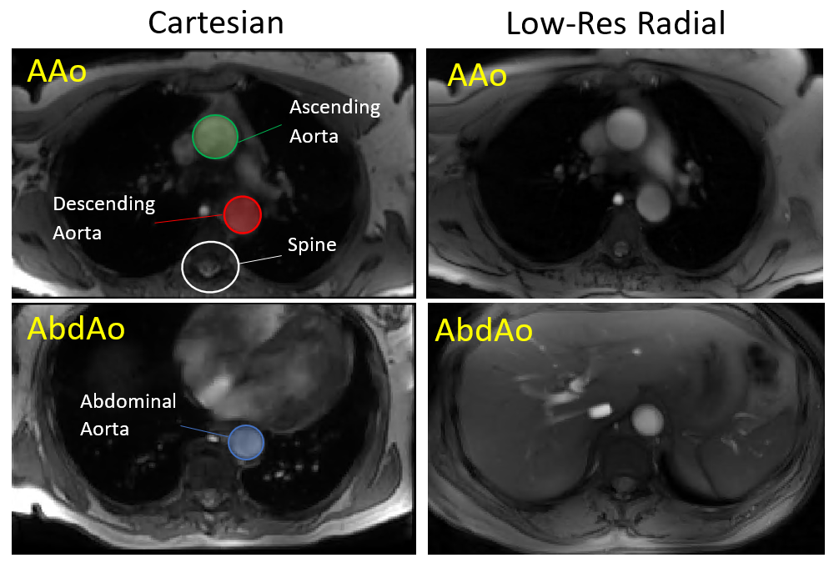

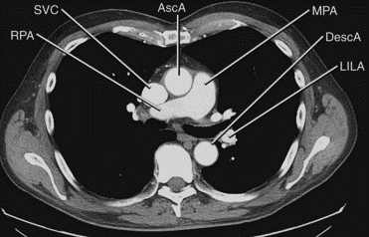

CT image   
from Google

* (Step 4) If you like the ROI, then select ‘Load ROI’.
  + 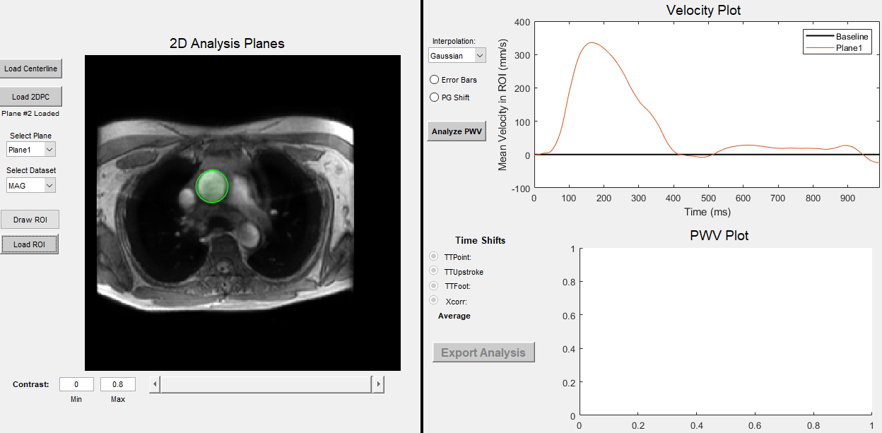This will load blood velocities within the selected ROI and will display the temporal waveform on the top right “Velocity Plot” panel.
* (Step 3) Now, we need to segment the descending aorta (DescAo). Select ‘Draw ROI’ and trace and ROI over the DescAo as we did before.
  + Hit ‘Enter’ on your keyboard when you are satisfied with the ROI placement.
* 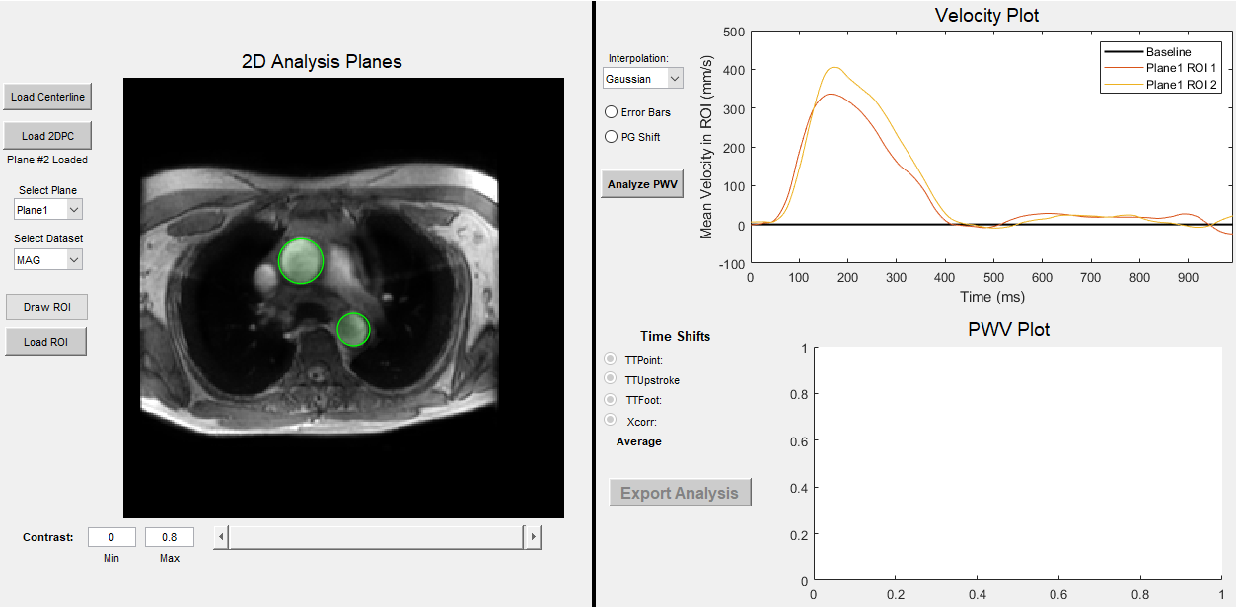(Step 4) Select ‘Load ROI’ and load the DescAo flow waveform into the ‘Velocity Plot’.
  + Note that the yellow DescAo flow waveform is shifted “past” the AscAo flow waveform. This is exactly what we should expect because the DescAo is downstream from the AscAo.
* (Step 3) Lastly, we need to segment the abdominal aorta (AbdAo).
  + 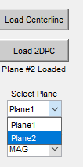We first need to change our imaging plane. Select “Plane2” from the ‘Select Plane’ dropdown.
  + Click ‘Draw ROI’ to trace your ROI as we have done before. Hit ‘Enter’ when finished drawing the ROI.
* 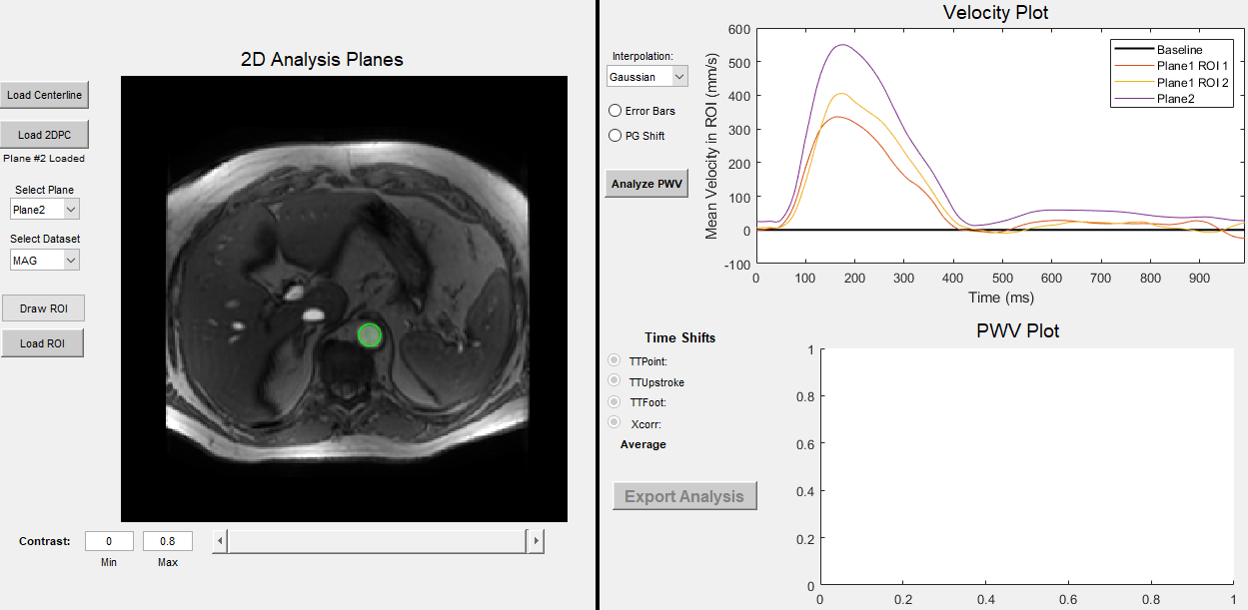(Step 4) Select ‘Load ROI’ and load the AbdAo flow waveform into the ‘Velocity Plot’.
  + 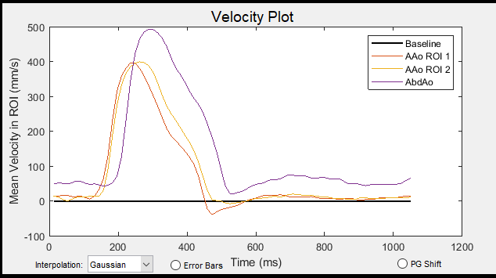**Just a note on this specific case, the purple AbdAo flow waveform does not appear to be shifted past the DescAo. This means that there is some issue with either the data quality or the gating.** It actually looks like the waveform precedes even the AscAo which we shouldn’t expect physiologically. In other words, we should expect the AbdAo waveform to be lagged or shifted past the DescAo. **It should look something like this:**
    - In this case, I would restart this case and just use the AscAo and DescAo data points.
    - 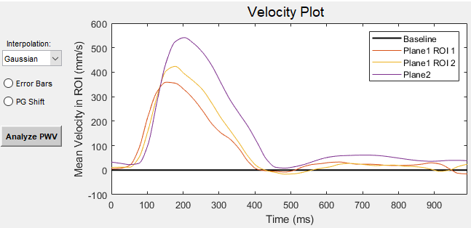**For now, I am going to artificially shift the AbdAo waveform for the purpose of this demonstration like so:**
* (Step 5) After we have loaded all 3 measurement points (AscAo, DescAo, AbdAo), we can now calculate the time shifts between these curves.
  + There are several buttons/features within the “Velocity Plot” graph shown above
    - Firstly, what we are looking at is the average velocity (in units of mm/s) within our ROIs over all frames. As seen in the plot above, we should see a peak in blood velocities (blood flow) during systole followed by decreased velocities during diastole. On the bottom, we are plotting 1 cardiac cycle in units of milliseconds. We can see that 1 cardiac cycle is ~1000 ms = 1 second = 60 beats per minute (a very normal heart rate).
    - There is an ‘Interpolation’ button which changes how the flow waveforms are [interpolated](https://en.wikipedia.org/wiki/Linear_interpolation) and smoothed. I suggest using [Gaussian smoothing](https://en.wikipedia.org/wiki/Gaussian_blur) which has shown the best results so far and has been used in previous studies. However, there is also an option for no smoothing (‘None’) if desired.
    - You can show the variance of each mean velocity measurement within an ROI (how wide the range in velocities are) by clicking the ‘Error Bars’ radio button. This shows error bars at each interpolated data point.
    - The ‘PG Shift’ radio button is a relic button. Previously, you would have to use this button to shift all of the waveforms for the Cartesian 2DPC datasets. This is because those exams are acquired with a different gating technique (prospective gating). The reason why it does this is a bit out of the scope of this discussion, but you can find a nice description in the [review paper by Joachim Lotz](https://pubs.rsna.org/doi/10.1148/radiographics.22.3.g02ma11651) (also a good introductory paper). Again, ignore this button because I have implemented a method to automatically shift these flow curves.
  + There is really not much we need to do with this plot. So, whenever we are ready, we can click the ‘Analyze PWV’ button to automatically calculate the time shifts between these flow curves. There are several methods that I use to calculate these time shifts:
    - **TTPoint = Time-to-point**
      * Time at which the flow curve is at it’s halfway point along the systolic upstroke (50% between minimum and maximum velocity).
    - **TTUpstroke = Time-to-upstroke**
      * Time where the flow curve has the highest acceleration. This is usually around the “notch” in the flow curve, where velocity really begins to increase rapidly.
    - **TTFoot = Time-to-foot**
      * This method fits a line to the upstroke portion of the flow curve (where flow increases linearly). Specifically, we find where the flow is at 20% peak and 80% peak and use linear regression to find the time at which the fitted line intercepts the x-axis (0 mean velocity).
    - **Xcorr = Cross correlation**
      * This method uses a mathematical technique called cross-correlation, which shifts one of the waveforms incrementally and sees the degree of overlap of the 2 curves. The shift that results in the maximum amount of overlap is the time shift we are looking to obtain.
    - More detailed information on these methods can be found in the [Andrew Wentland review paper](https://www.ncbi.nlm.nih.gov/pmc/articles/PMC3996237/pdf/cdt-04-02-193.pdf).
* We can now see a plot of centerline distances (x-axis) vs. time shift (y-axis) in the ‘PWV Plot’ panel.

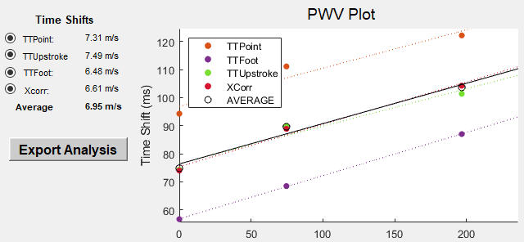

AAo

DescAo

AbdAo

* + The centerline distances (x-axis) are in units of millimeters. The first data point (at x=0) is the first measurement point (AscAo). The second set of points at x=75mm is the DescAo. This means that the DescAo is 75mm away from the AscAo. The last set of points at x=200mm is the AbdAo measurement point.
  + The different colored points are the different methods used to calculate time shifts (discussed above). Each of these will calculate slightly different time lags between the flow curves. Thus, we will have different PWVs associated with each method.
    - A quick note, it does not matter if the points from TTPoint are higher up than the points from TTFoot. What matters is how well the points fit along a line. For instance, the TTFoot points line up very well. However, the TTPoint points do not line up as well (i.e., there is more error associated with these measurements).
  + **PWV is calculated by fitting a line to each of the points.** For each method, the inverse of the slope is the pulse wave velocity. In other words, the inverse of the slope is the *rate* at which your pulse waves are travelling along your centerline. If you remember back to high school algebra, we know that y = mx + b and that our slope, m, is rise over run. Rise (y-axis) is the time shifts in units of milliseconds; run (x-axis) is the centerline distances in units of millimeters. Unitwise, this means our slope is in units of ms/mm. If we take the inverse, this flips the units to mm/ms = m/s. This is exactly the PWV measure we are after.
  + On the left side of the plot, we see the actual pulse wave velocity calculations for each time shift method.
    - Note that the title “Time Shifts” is actually a misnomer; these are PWV values in units of meters/second.
    - Note that there is an “Average” method, which averages the *time shifts* and computes PWV. This is not equivalent to averaging the individual PWV values.
  + You can click on the individual radio buttons to add/remove certain time shift methods.
    - 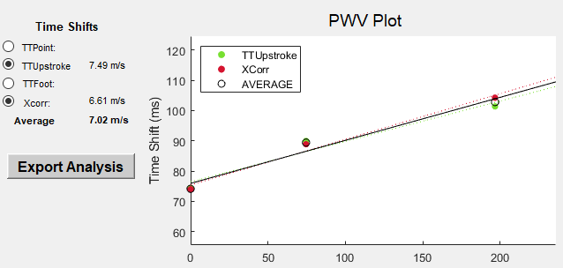For instance, I can remove TTPoint and TTFoot, like shown below:
    - There will be circumstances where a time shift method fails. This happens somewhat frequently. This is where the radio buttons come in handy.
* (Step 6) When ready, click ‘Export Analysis’ to save our flow data, screenshots of the ROIs and flow curves, and tabulated PWV values in an excel sheet.
  + When you click this button, you should see several plots pop-up and close. These are the time-to-shift calculations plotted on the flow curves and are being saved because they can be helpful for seeing if and/or why a time shift method is failing.
  + 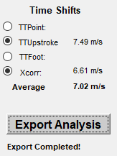Once the export is completed (less than a minute), you should see some text that reads “Export Completed!”.
  + You will see that this created a folder called ‘PWV_2DPC_Analysis’.
    - Inside are two folders. The ‘DataAnalysis’ folder contains the ‘Summary_*DATE*.xlsx’ excel sheet that contains the tabulated PWV values (which will be used in a later section). The ‘ROIimages’ folder contains images of the vessel segmentation in Step 3.
  + 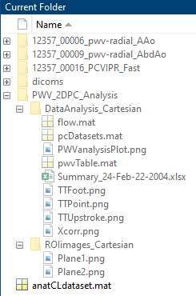We have now completed the PWV analysis for the Cartesian 2DPC exams.

---------------------------------------------------------------------------------------------------

* We now need to go back and repeat the same process for the Radial 2DPC scans.
* In the Matlab command window, type “>> close all; clear all; clc”.
* Re-open the PWV_2DPC interface by typing “>> PWV_2DPC” in the command window.
* Load the centerline by clicking ‘Load Centerline’ and loading the ‘anatCLdataset.mat’ file into PWV_2DPC.
* Click the ‘Load 2DPC’ button.
  + Now, we need to load in the aortic arch Radial 2DPC slice.
  + Move into the folder ‘#####_0000#_pwv_radial_AAo’, then the ‘10000p_40frames_1403res’ folder, then the ‘dat’ folder.

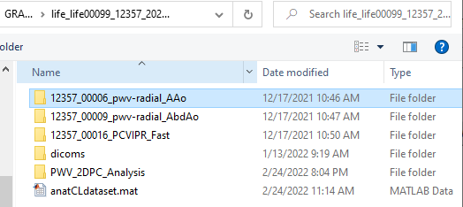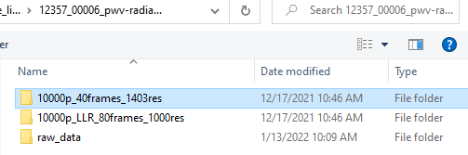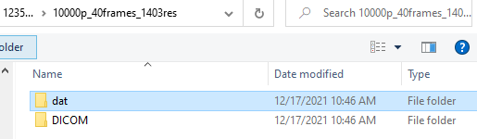

* + 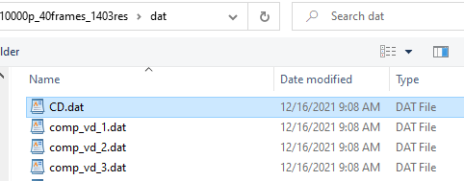Once in this folder, select any DAT file to load in the Radial 2DPC AAo slice and click ‘Open’.
  + 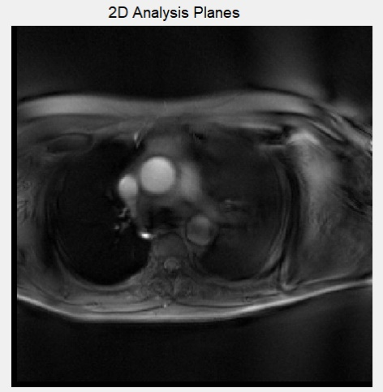You should see the Radial 2DPC AAo slice in the ‘2D Analysis Planes’ panel.
    - Notice that the anatomy is very similar to the Cartesian 2DPC AAo slice. However, there are certain differences with the radial acquisition. For instance, the aorta seems a bit blurred. This is likely due to some motion artifact, since the scan was done while the subject was not holding their breath (free-breathing).
* Click the ‘Load 2DPC’ button again.
  + Now, we need to load in the abdominal aorta Radial 2DPC slice.
  + Move into the folder ‘#####_0000#_pwv_radial_AbdAo’, then the ‘10000p_40frames_1403res’ folder, then the ‘dat’ folder.
  + Once in this folder, select any DAT file to load in the Radial 2DPC AAo slice and click ‘Open’.
  + 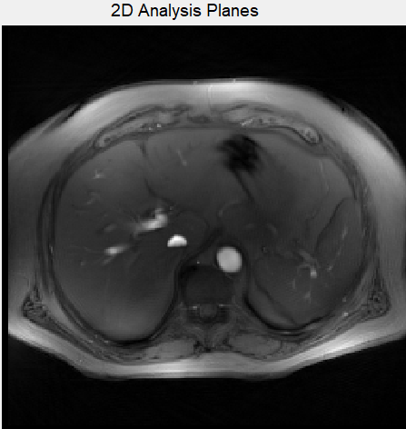This will load the second plane. If you click “Plane2” in the ‘Select Plane’ dropdown, we can see the abdominal aorta slice.
* 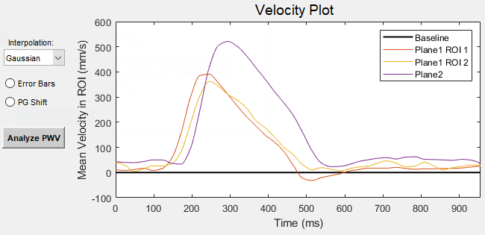Draw ROIs for the AscAo, DescAo, and AbdAo vessel segments (‘Draw ROI’) and load the velocity data (‘Load ROI’).
  + The flow curves should look similar to the Cartesian 2DPC datasets.
* 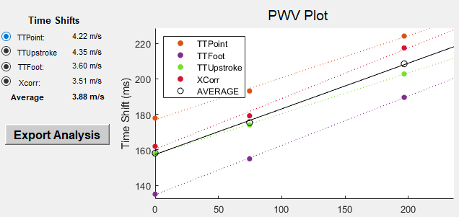Click ‘Analyze PWV’.
  + We should expect that PWV values for the Radial 2DPC scan be similar to the Cartesian 2DPC scans. However, this often not the case. We are still not exactly sure why we there are differences. We need to perform some validation testing in a phantom to get to the bottom of this (which will likely be within the next few months).
* Now, we can export the data by clicking ‘Export Analysis’.
  + 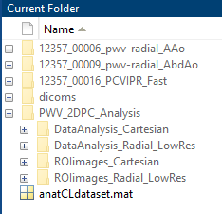If we look in our folder, we see that the ‘PWV_2DPC_Analysis’ folder now has two additional folders: ‘DataAnalysis_Radial_LowRes’ and ROIimages_Radial_LowRes.

---------------------------------------------------------------------------------------------------

* We now need to go back and repeat the same process for the Radial 2DPC LLR scans.
  + Remember, these are the high-resolution datasets (80 frames) that we reconstructed with a special “local low rank” (LLR) reconstruction.
* Close out of the PWV_2DPC window, clear the Matlab variables, and re-open ‘PWV_2DPC’
* 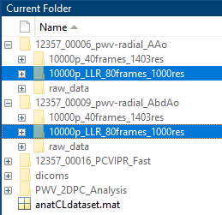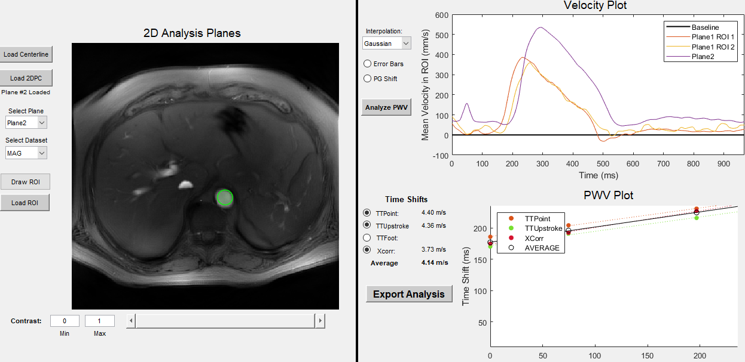Follow the same steps as above. The only difference is that you will ‘Load 2DPC’ data from the ‘10000p_LLR_80frames_1000res’ folder.
  + For this particular analysis, the TTFoot method failed. I removed it from the plot, however, when we click ‘Export Analysis’, that data will still be saved.
* After finishing the LLR datasets, you should have 6 total folders in the ‘PWV_2DPC_Analysis’ folder.

**Please email me if you have any questions. I know this is quite a bit of information, I just wanted to be throurough so everthing stands alone. Some of this may be information you already know or have read in the literature review papers I provided; this would be a much different document were it not for COVID19. Good luck!**

**Email: gsroberts@wisc.edu**